Create another procedure vkemp1.

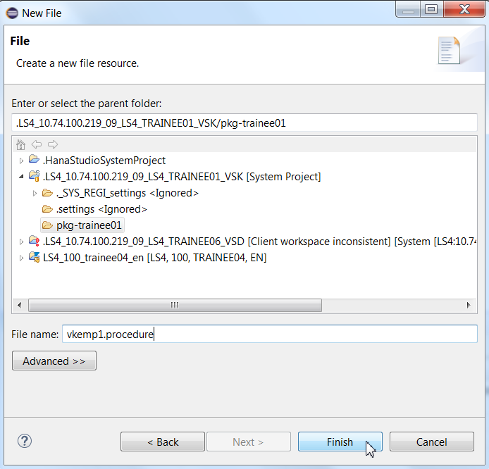

CREATE TYPE EMPTYPE AS TABLE ( DEPTNO NVARCHAR(2), SAL DECIMAL(7,2) ); 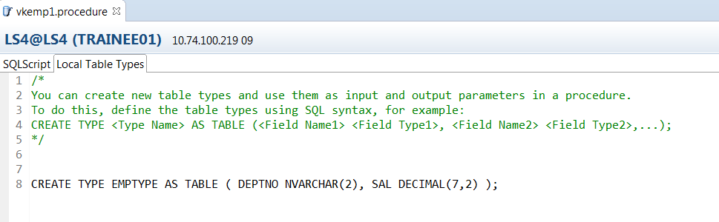

CREATE PROCEDURE vkemp1 ( OUT RES_TAB EMPTYPE )

LANGUAGE SQLSCRIPT

SQL SECURITY INVOKER

--DEFAULT SCHEMA <default_schema_name>

READS SQL DATA AS

BEGIN

/*****************************

Write your procedure logic

*****************************/

RES_TAB = SELECT DEPTNO , SAL FROM SAPLS4.Z104329EMP;

END;

Check and Activate.

Go to Modeler Perspective. Search for your procedure. Open SQL.

Drag Procedure and execute.

